This information was copied from this web page:
https://gravitywinehouse.com/blog/winery-sanitation-paa-ozone/
WINERY SANITATION: AN ANALYSIS OF PERACETIC ACID VS. OZONE
MARCH 9, 2018
BY GRAVITY WINE HOUSE
Adhering to a strict cleanliness and sanitation routine is one of the most essential practices in a winery. Proper sanitation heavily influences the quality, safety, and consistency of the wine being produced. Sanitizing the winery equipment and surfaces is required to minimize microbial growth environments and to reduce their counts to non-threatening levels. Without proper sanitation, microorganisms (such as Acetobacter) may come in contact with the wine and produce off-flavors and aromas. Although a number of different methods exist to sanitize winery equipment, two of the most effective methods are peracetic acid and ozone.
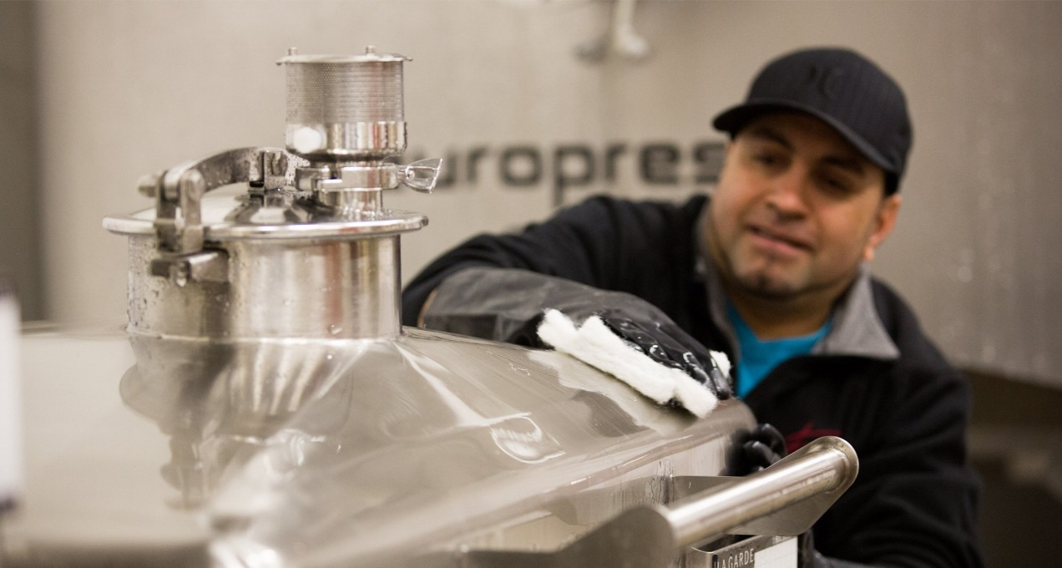

Method One ~ Peracetic Acid
Peracetic acid (also known as peroxyacetic acid or PAA) is a colorless liquid formed by the mixture of acetic acid and hydrogen peroxide. Allowed by the National Organic Program (NOP) as a disinfectant, it is widely praised for its effectiveness as an antimicrobial at broad temperature (between 0-40°C) and pH [between 3.0-7.5 (Orr)] ranges. Peracetic acid’s ability to perform efficiently at low temperatures promotes energy efficiency; using ambient temperature water eliminates the time, cost, and energy involved when diluting sanitizing agents with hot water.

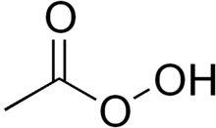Other benefits to using peracetic acid include:
- Its above average oxidation capacity (Heritage Systems 2005). Oxidation capacity allows the sanitizing agent to interact with organic material (soil) upon contact and oxidize it to form hydroxyl radicals, permitting the destruction of bacterial cell structure and killing the cells (Orr).
- Its success in penetrating and/or dispersing biofilms (Premium…). Biofilms may be formed on winery equipment, such as stainless steel, when bacteria adhere to the surface and are able to multiply into colonies creating a “film” (Fugelsang and Edwards 2007). The dense, cohesive nature of biofilms makes their removal difficult. Using a sanitizer with the removal properties of peracetic acid is advantageous.
- The convenience of testing peracetic acid’s concentration is another advantage. Inexpensive, manual test kits may be purchased to verify the concentration of peracetic acid being used within the winery. A test strip is submerged into the peracetic acid solution. Within seconds, the strip can be compared to a color chart that determines the pH of solution or concentration in parts per million (ppm). Determining the correct concentration of sanitizer is being used is fundamental to its sanitizing efficiency.
Disadvantages to using peracetic acid include that, in its concentrated form, peracetic acid is corrosive and may cause skin, eye, and respiratory damage if improperly handled (Orr).

Method Two ~ Ozone
Ozone is another widely accepted and efficient sanitizing agent used in wineries that is USDA certified for organic processing facilities. Like peracetic acid, ozone has a high oxidation capacity and causes cell lysis when it encounters organic material. Ozone functions at maximum efficiency as a sanitizing agent because its potency prevents microbes from acquiring a tolerance to it.
Ozone (also known as O₃) exists as a pale blue gas which, when dissolved in water, creates a liquid solution (Ozone…2014). The ozone molecule is made up of three oxygen atoms O₃, making it an extremely unstable compound that naturally and quickly decomposes into O₂.
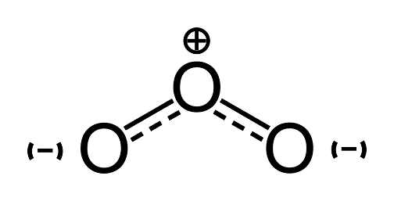
This provides wineries with several merits including:
- It is considered environmentally friendly as a “natural sanitizer” (Heritage Systems 2005).
- No damage is caused to winery equipment sanitized with ozone and there are no residual compounds left behind, because oxygen is non-toxic and readily exists as a gas.
- Ozone transportation and storage issues are minimized within the winery because on-site storage is impossible due to its molecular volatility. Instead, ozone is generated on-demand using specific machinery which reduces waste as well as chemical-related costs and frustrations.
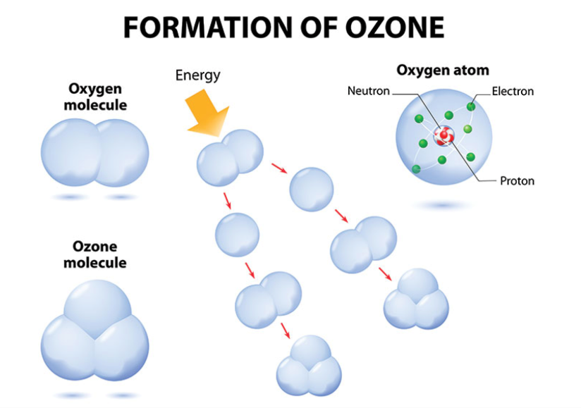
source: Restoration & Remediation

Disadvantages to using Ozone include:
- Unlike peracetic acid, the start-up costs and procedures to implement ozone sanitation may be overwhelming. An “ozone generator” functions by compressing oxygen in the air and exposing it to either ultraviolet light or an electrical current. This process separates the two oxygen atoms of O₂ into single oxygen anions. These anions desperately want to stabilize and consequently attach onto other O₂ molecules, turning them into ozone as O₃ (Corona…). The generator uses a vacuum to introduce the newly created ozone into cold water for dispersion (Coggan c2002-2003).
- Ozone generators are costly; time must be dedicated to properly train employees on its usage.
- The concentration of ozone produced by the generator may be difficult to predict and monitor. The concentration of ozonated water depends upon temperature and pressure. Cold water and high pressure within the closed system of the generator are ideal environments for water to dissolve the ozone. However, as soon as the ozonated water strikes the ambient air temperature and atmospheric pressure, the extra ozone gas begins to bubble out of solution (Coggan c2002-2003). Electronic ozone meters which deliver an immediate digital reading can be purchased. An alternative, less expensive method is to use a manual test kit which operates similar to the peracetic acid kit described earlier. Whichever method is used, it is essential that the concentration be properly tested and monitored for sanitation effectiveness as well as employee safety.
- Ozone should be generated and utilized in low concentrations for its ability to irritate the respiratory system, as well as cause headaches and fatigue.
Both peracetic acid and ozone are recognized as industry leaders for sanitization methods. However, we at Gravity Wine House choose peracetic acid as our sanitation method. We like to keep our processes simple and effective. The fact that peracetic acid does not require machinery (or even electricity to prepare) is an important point for us, and allows our sanitation standards to be maintained under any circumstances.

